**Poly-substance use, treatment completion, and contact with the justice system: a multistate analysis of treatments for substance use disorders between 2010-2019, Chile**

Andrés González-Santa Cruz a.b,c; José Ruiz-Tagleb,c Mariel Mateo Pinones b,d; Álvaro Castillo-Carniglia b,c,e;

a School of Public Health, Universidad de Chile, Chile

b Millennium Nucleus for the Evaluation and Analysis of Drug Policies (nDP), Chile.

c Society and Health Research Center, Facultad de Ciencias Sociales y Artes, Universidad Mayor, Santiago, Chile.

d Griffith Criminology Institute, Griffith University, Australia

e Millennium Nucleus on Sociomedicine (SocioMed), Chile.

**2023 Abstract categories**: Global Health, Substance Use

**Characters (w/ space)**: 2,013/2,000 (depending on the selected figure [only one], we will erase >33 characters by deleting the title and needed to comply with the limits)

**Background**: Substance use can affect health and multiple social dimensions, including criminal behaviors and the likelihood of contacting the criminal justice system. We aim to estimate the effects of polysubstance use at baseline (vs single substance use) on the probabilities of (i) completing baseline drug treatment and (ii) contacting the criminal justice system after treatment, using multistate survival models at 1-, 3- and 5-years follow-ups.

**Methods**: We used a population-based record-linkage retrospective cohort, merging records of adults in publicly funded Chilean SUTs programs with the Prosecutor’s Office (PO) data of offenses at the national level between 2010-2019. Patients were weighted by the inverse probability of polysubstance use based on several predictors; Weights were truncated at the 1st and 99th percentiles. We then calculated Aalen-Johanssen estimator for transition probabilities. Codes and markdown are available at bit.ly/3w9wygJ.

Figure 1. Multistate scheme

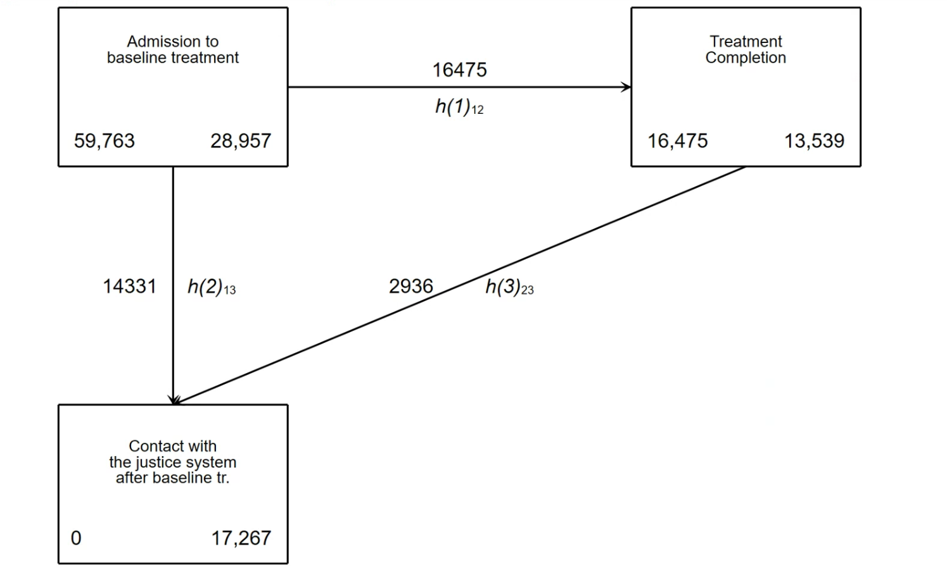

**Results**: Of the 85,048 SUT patients with one or more treatments between 2010 and 2019, 70,863 (83%) were eligible to be matched with PO data. Of the sample, 19,276 (27%) completed baseline treatment, and 22,287 (31%) had a contact (an offense that ended with a condemnatory sentence).

Figure 2: Graphical Representation of SMDs

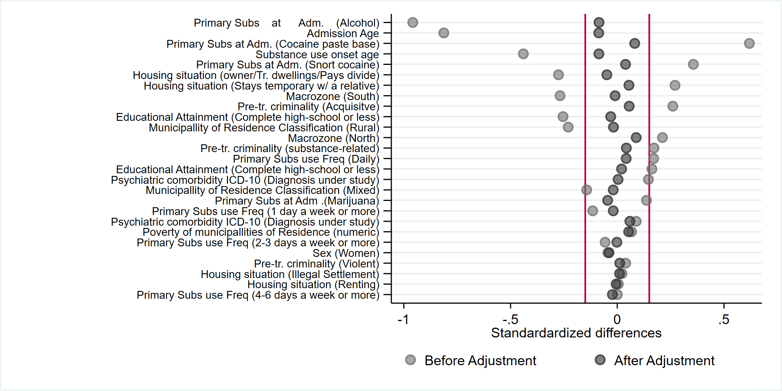

Note: Red lines depict SMDs |0.15|

We obtained 59,763 patients with 16,475 (28%) complete treatments and 17,267 (29%) with offenses.

The lowest differences were at one year. People with polysubstance use at baseline had lower likelihoods of treatment completion (14.4% 95% CI 14.1%, 14.6%) than people with single substance use (17.2% 95% CI 16.9%, 17.6%). Polysubstance users had greater likelihoods of contact with the justice system (incomplete: 7.5% 95% CI 7.3%, 7.8%; complete: 8.5% 95% CI 7.4%, 9.6%) than single-substance users (incomplete: 6.4% 95% CI 6.2%, 6.6%; complete; 4.5% 95% CI 3.9%, 5.2%).

**Conclusions**: People with polysubstance use had lower probabilities of completing baseline treatment and were more likely to experience criminal offenses.

**Funding**: This work was funded by ANID - Millennium Science Initiative Program - N° NCS2021_003 (Castillo-Carniglia) and N° NCS2021_013 (Calvo)

## CORREGIDO FINAL

**Background**: Substance use can affect health and multiple social dimensions, including criminal behaviors and the likelihood of contacting the criminal justice system. We aim to estimate the effects of polysubstance use at baseline (vs single substance use) on the probabilities of (i) completing baseline drug treatment and (ii) contacting with the criminal justice system after treatment, using multistate survival models at 1-, 3- and 5-years follow-ups.

**Methods**: We used a population-based record-linkage retrospective cohort, merging records of adults in publicly funded Chilean SUTs programs with the Prosecutor’s Office (PO) data of offenses at the national level between 2010-2019. Patients were weighted by the inverse probability of polysubstance use based on several predictors; Weights were truncated at the 1st and 99th percentiles. We then calculated Aalen-Johanssen estimator for transition probabilities. Codes and markdowns are available at bit.ly/3w9wygJ.

**Results**: Of the 85,048 SUT patients with one or more treatments between 2010 and 2019, 70,863 (83%) were eligible to be matched with PO data. Of the sample, 19,276 (27%) completed baseline treatment, and 22,287 (31%) had contact with the justice system.

We obtained 59,763 patients with 16,475 (28%) complete treatments and 17,267 (29%) with at least one contact with the justice system.

The lowest differences were at one year. People with polysubstance use at baseline had lower likelihoods of treatment completion (14.4% 95% CI 14.1%, 14.6%) than people with single substance use (17.2% 95% CI 16.9%, 17.6%). Polysubstance users had greater likelihoods of contact with the justice system (incomplete: 7.5% 95% CI 7.3%, 7.8%; complete: 8.5% 95% CI 7.4%, 9.6%) than single-substance users (incomplete: 6.4% 95% CI 6.2%, 6.6%; complete; 4.5% 95% CI 3.9%, 5.2%).

**Conclusions**: People with polysubstance use had lower probabilities of completing baseline treatment and were more likely to contact the justice system.

# 7 mar 2023 | Reunión

* 12 marzo= Intro y métodos más o menos estructurados
* Semana del 20, a ACC
* ¿ Por qué estudiar policonsumo como un tto.?
* Indicar períodos de análisis (6 meses, 1 año, 3 años)

___________________________________

Postulación al fondo

*Un/a mismo/a investigador/a podrá enviar más de una propuesta, pero no podrá adjudicarse más de un fondo como investigador/a responsable en este concurso. Quienes se hayan adjudicado un fonde en el concurso 2022 podrán enviar nuevas propuestas, pero deberán ser diferentes y generar productos distintos a los planteados en la primera adjudicación. Los recursos, administrados a través de un centro de costos, podrán ser utilizados para la contratación de ayudante/s, compra de insumos, viajes y viáticos, inscripción a congresos y membresías, pago de incentivos, entre otros (el marco para efectuar gastos son los que establece la Iniciativa Científica Milenio de ANID). Los/as investigadores/as postdoctorales contratados por nDP, los/as investigadores/as senior y los/as investigadores/as principales no podrán recibir incentivos económicos. Los/as investigadores/as que se adjudiquen un fondo deberán presentar a los 6 meses un estado de avance y a los 12 meses los productos exigidos/propuestos.*

## Background (500 palabras)

*Emphasize: (1) the theoretical-conceptual and state-of-the-art developments that underpin the proposal, and (2) the scientific or technological novelty of the proposal. After reading this section it should be clear how this research will fill a relevant gap in extant knowledge and has the potential to change the direction of research (theory and methods worldwide) and practice (interventions and policy making in Chile and abroad), or at least to make a substantial contribution to an important area of research or clinical practice. Proposals that make an incremental contribution extending or qualifying previously work are rarely funded.]*

*-Implicancias para las pol publicas (justificacion), justificar cómo será un aporte*

Substance use disorders(SUD) are often related to criminality, such as reincarceration(Thomas et al., 2022), arrests(Sugie & Turney, 2017), and violence (Duke et al., 2018). People with SUD are also commonly polysubstance users (PSU)(Liu et al., 2018), conceived as the use of multiple substances, generally illicit, over an established timeframe (Connors, 2014).

People with co-occurring use tend to have more problems in various dimensions compared to single users. It is related to poorer treatment outcomes, greater SUD severity (Crummy et al., 2020; Quek et al., 2013), and the prevalence of polysubstance use tends to be higher among users in contact with the criminal justice system (CJS) (Ford et al, 2022; Skjærvø et al., 2016). Research conducted in North America, Europe, and Australia has shown that the use of multiple substances leads to a higher mortality rate (Gjersing & Bretteville-Jensen, 2018), is related to post-traumatic stress disorder (Hassan & Le Foll, 2019), and increases the risk of relapse compared to single-substance use (Gjersing & Bretteville-Jensen, 2018; Wang et al., 2017).

Research on polysubstance use in Latin America is considerably limited (Lalwani et al., 2022), furthermore, like many studies in the global north, high-risk populations have often been overlooked(Reyes et al., 2013). An analysis of data from independent studies conducted in six latin american countries found that about 21% of participants reported polydrug use, and males, people aged 18-34 years, from Chile, Uruguay, and Argentina were more likely to report polydrug use after adjusting for age and sex (Reyes et al., 2013). In addition, different studies in the region have associated polysubstance use with more susceptibility to risky sexual behaviors (Meacham et al., 2018), rurality and unemployment (Lalwani et al., 2022), earlier onset use, socioeconomic difficulties, lower educational attainment, and families engaged in dysfunctional practices (Herrera-Rodriguez et al., 2012). Studies conducted in hard-to-reach populations in Chile have associated polysubstance use with school drop-out, unemployment, sexual risk behaviors, and antisocial behavior (Santis 2007; Olivari et al., 2022; Vilugron et al., 2022).

One major issue highlighted in the literature is the role of treatment in patients’ life-course trajectories. Studies have found that patients who complete treatment have better outcomes than those who leave against medical advice, but completion rates may be influenced by patient characteristics (White, 2012; Andersson et al., 2019 ). According to a systematic review of US veterans, completing a substance use intensive outpatient treatment program is associated with a lower likelihood of being arrested or incarcerated among veterans compared to those who did not (Timko et al., 2020). Another study found that prior SUD treatment episodes are a protective factor for criminal arrest(Nkemjika et al., 2022).

Despite that the relation between SUD and contact with CJS is well documented, little is known about the effect of treatment outcome among this population. Thus, this study aims to estimate the mediator effects of completing a SUD treatment on the relationship between polysubstance use and contact with the criminal system among adult patients admitted to SUD treatment programs in Chile during 2010-2019. Understanding the relationship between polysubstance use at admission and contact with the criminal justice system could inform effective prevention and intervention strategies. In addition, this study could provide insight into the effectiveness of substance use disorder treatment in reducing the risk of contact with the criminal justice system among individuals with baseline polysubstance use in Chile. This study contributes to a growing literature on the importance of addressing longitudinal dynamics in SUD patients.

**Falta agregar:**

**Bunting. Polysubstance Use Patterns among Justice-Involved Individuals Who Use Opioids 10.1080/10826084.2020.1795683**

**Bunting.Polysubstance use and re-incarceration in the 12-months after release from jail: a latent transition analysis of rural Appalachian women. https://doi.org/10.1080/00952990.2021.1995402**

## Research questions, aims, and hypothesis

- Research Question: What is the effect of completing a substance use disorder treatment on the relationship between baseline poly-substance use and contact with the criminal system in Chile?

- Goal: Estimate the mediator effects of completing a SUD treatment on the relationship between poly-substance use and contact with the criminal system among adult patients admitted to substance use disorder treatment programs in Chile during 2010-2019.

Specific aims:

1. To describe the role of poly-substance use on being in contact with the criminal system.
2. To compare the risk of being in contact with the criminal system between poly-substance users and single-substance users.
3. Estimate the combined effects of exposure to poly-substance use at admission and treatment outcome on the contact with the criminal system.
4. Exposure to substance use at baseline is related to lower treatment completion rates.
5. Exposure to substance use at baseline is related to a greater risk of contact with the criminal system.
6. Vulnerable patients have a differential risk of contact with the criminal system associated with treatment completion.
7. Polysubstance use at baseline admission and treatment completion will be antagonistically related to increased risk of contact with the criminal system.

## Methodology

**Design**

We will use a population-based record-linkage retrospective cohort, merging records of adults (18+ years of age) in publicly funded Chilean SUTs programs from the electronic clinical record system (SISTRAT), with the Prosecutor’s Office (PO) data of offenses at the national level between 2010 and the third quarter of 2019. Only de-identified individual-level data will be used for the proposed study; thus, the study is considered of negligible risk and can be exempted from ethics review.

**Outcome variable**

*Treatment outcome:* Completion of treatment: Transformed into a dichotomous variable to indicate treatment completion (1= reasonable accomplishment of treatment goals so the treatment is no longer needed formally speaking) or non-completion (0= Leaving against professional advice, due to disciplinary dismissal or due to drop-out).

*Contact with the criminal system*: From a record in which the patient had an offense that ended with a condemnatory sentence after the treatment outcome. The date will be the date of the commission of the offense. Time will be measured in years or months.

**Exposure**

*Polydrug use***:** The report of the individual using more than one primary (main) substance at admission to treatment (Font-Mayolas & Calvo, 2022).

**Covariates**: The following potential confounding variables available in the database will be considered: Primary substance at admission, Admission age, Substance use onset age, Housing situation, Macrozone, Pre-treatment criminality, Educational attainment, Municipality of residence rurality classification in 2017 CENSUS, Primary substance use frequency, Psychiatric comorbidity (ICD-10th), Biennial poverty index of the municipality of residence, and Sex. Excluding municipality indexes, the covariates being studied are fixed at the entry of the study.

**Data analysis**: We used a survival framework to calculate the time to an event of treatment outcome and contact with the criminal systems. All individuals were censored at the end of the study period (November 13, 2019).

The main analytic approach will consider modelling the primary outcomes as a function of the exposure variables through multi-state models (64). We will analyze the different disease pathways and the associations between intermediate effects and a previous one through a parametric multi-state model that allows specifying different distributions, using the multistate package in Stata (v.16, Stata Corp, College Station, Texas) (65, 66). The illness-death model is a widely adopted multistate survival model in which three states are defined: health, illness, and death. In our case, the model would allow for transitions between admission and treatment outcome, treatment outcome (completing treatment) and contact with the criminal system, and admission and contact with the criminal system (without completing treatment). To account for residual confounding, patients will be weighted by the inverse probability of baseline polysubstance use according to covariates; weights will be truncated at the 1st and 99th percentiles (Cole & Hernán, 2008).

The Aalen-Johansen estimator is used to estimate the transition probabilities for a population. These probabilities represent the likelihood of the process of interest in being in a particular state, given that it was in another state at a previous time. Specifically, the probabilities take the form Pr(X(t) = j| X(s) = h), where X(t) is the process of interest at time t, and h and j are possible states of the process X(t).

*Secondary analyses*: We utilized a survival analysis-based approach for conducting mediation analysis, which has been done in previous research (11, 12, 13, 14). To estimate the effects of polysubstance use at admission to baseline treatment on time to contact with the criminal system at 6 months, 1 year, and 3 years, we employed the Stata PREDICT, MEANSURV post-estimation command. This method relies on a fitted flexible parametric model in the case of non-proportional hazards, by selecting spline basis functions, to achieve a high degree of flexibility in estimating the baseline hazard (13). In our analysis, we considered the baseline treatment outcome as the mediator and adjusted for the same covariates used for the inverse probability weights for the multistate model. We calculated the proportion mediated at 6 months, 1 year, and 3 years since admission (i.e., the follow-up period), and estimated 95% confidence intervals (CIs) using the bootstrap method with 2,000 replications. We performed all statistical analyses using Stata v.16 (College Station, TX). Another alternative contemplates using “RISCA” for multistate models and “WeightIt” package for adjustment using IPWs or “mediation” package for mediation analysis for survival data in R version 4.1.2. Codes and markdowns of preliminary analyses are available at bit.ly/3w9wygJ.

## Project milestones

**Progress report**: It will include: This progress report will include a theoretical framework and descriptive analyses exploring the connections between polysubstance use, SUT outcome, and contact with the criminal system (Aim 1).

**Paper**: The paper will be sent to a Substance Abuse, Criminology, or Public Health International Journal before the twelfth month of the study (Aim 1 and 2)

**Presentation in Scientific meetings**: Our goal is to present this study at least at one international conference such as the National Institute on Drug Abuse International Forum, Society for Epidemiologic Research, or similar, and in possible scientific community activities organized either by Griffith University (Australia), Universidad de Chile, Universidad Mayor or other national institutions.

## Research team

**Table 1. Research Team**

|  | Role | Expertise | Time spent on the project |
| --- | --- | --- | --- |
| Andrés González | P.I. | Ph.D. student (School of Public Health, Universidad de Chile). He has worked as technical staff in research related to occupational health and substance use treatments. He has been working on the Treatment patients dataset since 2019, collaborating with Dr. Castillo-Carniglia in the analysis of several papers | *6 hours per week* |
| José Ruiz-Tagle | Co-I | Ph.D. student (Public Policy, Universidad Mayor). He has worked in research projects related to substance use treatments. He also has been working on the dataset on Treatment patients since 2019 along with Dr. Castillo-Carniglia. He collaborated in the analysis of several papers linked to substance use. | *3 hours per week* |
| Mariel Mateo | Co-I | Ph.D. student (School of Criminology and Criminal Justice, Griffith University, Australia). She coordinated the first Outcome Study of Substance Use Treatment in Chile [15] and led the Drug research area in the Justice and Society Studies Centre (Pontificia Universidad Católica) between 2015 and 2019. | *2 hours per week* |
| *Álvaro Castillo-Carniglia* | Sup. | Ph.D., Associate professor, and Director of the Ph.D. Programme in Public Policy, Universidad Mayor. He has background in epidemiology and his main research areas are the measurement of alcohol and other drug use in the population. He has co-directed several theses in public health related to treatment dropouts and readmissions. | *2 hours fortnight* |
| *Note: P.I.: Principal Investigator; Co-I: Co-Investigator; Sup.: Supervisor.* | | | |

## Timeline

**Figure 1. Gantt chart of activities involved in research progress**

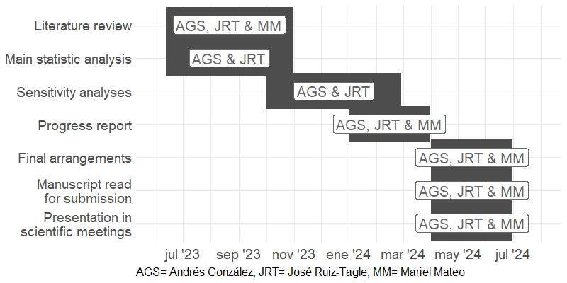

## Budget

**Breve justificación y descripción del uso que se dará a los recursos solicitados**

For 2020, the average monthly remuneration for professionals with postgraduate studies was 1,655,484 CLP. In this case, the three young researchers in this project hold postgraduate degrees. If we multiply 45 hours by 4.345 weeks (average weeks per month), we have an average of 196 hours per month. Therefore, when the mentioned remuneration is divided by 196 hours, it gives a valuation of 8,446 CLP per hour. Considering that there are 45 weeks (52.2 weeks between July 1, 2023, and July 1, 2024, discounting holidays and breaks), and even if they only work for one hour per week, it is reasonable that they receive an approximate amount of 380,070 CLP. However, a significant part of the resources will be allocated to academic activities such as conferences or seminars, which is our main interest in the context of the nucleus nDP. The costs of attending international conferences are between 2,000-4,000 USD (Sarabipour et al 2020). Hence, the fund should cover a valuable part of our expenses given the costs.

Additionally, we aim to allocate the funds towards an annual subscription to DataCamp Teams (<https://www.datacamp.com/pricing?tab=workspace>), which consists of a private and secure virtual workspace to coordinate the analyses and not depend on hardware limitations. This service costs 16.59 USD (199.08 USD annually), assuming an exchange rate of 800.75 CLP, resulting in 159,413 CLP annually.

Fuentes:

<https://chile.workingdays.org/mobile_home.php>

<https://es.planetcalc.com/7741/>

<https://www.meganoticias.cl/dato-util/359248-sueldos-posgrado-magister-doctorado-becas-chile-23-11-2021.html>

Sarabipour, S., Khan, A., Seah, S., Mwakilili, A. D., Mumoki, F. N., Sáez, P. J., … Mestrovic, T. (2020). Evaluating features of scientific conferences: A call for improvements. doi:10.1101/2020.04.02.022079

# Bibliografía

# IDENTIFYING CAUSAL MECHANISMS (PRIMARILY) BASED ON INVERSE PROBABILITY WEIGHTING.<https://doi.org/10.1002/jae.2341>

**Timko C, Nash A, Owens MD, Taylor E, Finlay AK. Systematic Review of Criminal and Legal Involvement After Substance Use and Mental Health Treatment Among Veterans: Building Toward Needed Research. Substance Abuse: Research and Treatment. 2020;14. doi:10.1177/1178221819901281**

* In addition, longer treatment was associated with better outcomes among alcohol and drug patients,42,49 and treatment completion (which cannot be achieved if patients are detained or reincarcerated during treatment) was related to a lower likelihood of incarceration than was non-completion.

**VILUGRON, Fabiola; MOLINA G., Temístocles; GRAS-PEREZ, María Eugenia y FONT-MAYOLAS, Sílvia. Precocidad de inicio del consumo de sustancias psicoactivas y su relación con otros comportamientos de riesgo para la salud en adolescentes chilenos. Rev. méd. Chile [online]. 2022, vol.150, n.5 [citado 2023-03-09], pp.584-596. Disponible en: <http://www.scielo.cl/scielo.php?script=sci_arttext&pid=S0034-98872022000500584&lng=es&nrm=iso>. ISSN 0034-9887. http://dx.doi.org/10.4067/s0034-98872022000500584.**

e la razón entre adolescentes que reportan a: consumo de sustancias psicoactivas en el último mes, b: conductas suicidas, c: comportamientos sexuales de riesgo y d: hábitos alimentarios no saludables versus los que no, es significativamente mayor en adolescentes con policonsumo precoz de tres sustancias para: a: tabaco (OR: 78,00; 95% IC: 23,92-254,36); marihuana (OR: 68,95; 95% IC: 26,61-178,67); alcohol (OR: 39,11; 95% IC: 18,79-81,40), b: ideación suicida (OR: 2,59; 95% IC: 1,53-4,39); intento de suicidio (OR: 2,37; 95% IC: 1,35-4,15); planificación suicida (OR: 2,36; 95% IC: 1,36-4,09): actividad sexual (OR: 9,87; 95% IC: 5,83-16,70), c: actividad sexual temprana (OR: 8,67; 95% IC: 5,23-14,39); uso infrecuente de preservativo (OR: 5,19; 95% IC: 2,84-9,49), d: bajo consumo de frutas y verduras (OR: 2,65; 95% IC: 1,38-5,09) y consumo infrecuente de desayuno (OR: 2,23; 95% IC:1,44-3,45), comparado con aquellos sin policonsumo precoz de sustancias. Además, la razón entre adolescentes que reportan episodio de consumo intenso de alcohol, consumo diario de tabaco y consumo diario de marihuana versus los que no, es significativamente mayor en adolescentes con policonsumo precoz de tres sustancias (OR: 7,41; 95% IC: 2,57-21,39; OR: 15,71; 95% IC: 2,07-118,99 y OR: 8,29; 95% IC: 2,45-28,07 respectivamente), comparado con aquellos con consumo precoz de una sustancia

resumen: risky behavior such as suicidal intentions, sexual riesky behavior poorer food patterns

**Bunting. Polysubstance Use Patterns among Justice-Involved Individuals Who Use Opioids 10.1080/10826084.2020.1795683**

**Bunting.Polysubstance use and re-incarceration in the 12-months after release from jail: a latent transition analysis of rural Appalachian women. https://doi.org/10.1080/00952990.2021.1995402**

**Crummy. One Is Not Enough: Understanding and Modeling Polysubstance Use. 10.3389/fnins.2020.00569**

**Meacham MC, Roesch SC, Strathdee SA, Lindsay S, Gonzalez-Zuniga P, Gaines TL. Latent classes of polydrug and polyroute use and associations with human immunodeficiency virus risk behaviours and overdose among people who inject drugs in Tijuana, Baja California, Mexico. Drug Alcohol Rev. 2018;37(1):128-136. doi:10.1111/dar.12524**

**Shaoling Zhong, Rongqin Yu, Seena Fazel, Drug Use Disorders and Violence: Associations With Individual Drug Categories, Epidemiologic Reviews, Volume 42, Issue 1, 2020, Pages 103–116,** [**https://doi.org/10.1093/epirev/mxaa006**](https://doi.org/10.1093/epirev/mxaa006)

Individuals who engage in polydrug use, or the use of multiple drugs at the same time, were more likely to exhibit violent behavior. This was particularly true for individuals who used both stimulants and opioids. Additionally, the study found that individuals who used multiple drugs were more likely to have a drug use disorder and experience other risk factors for violence, such as childhood trauma and mental health issues. Overall, the findings suggest that polydrug use is a significant risk factor for violence in individuals with drug use disorders.

**Olivari, C. F., Gaete, J., Rodriguez, N., Pizarro, E., Del Villar, P., Calvo, E., & Castillo-Carniglia, A. (2022). Polydrug Use and Co-occurring Substance Use Disorders in a Respondent Driven Sampling of Cocaine Base Paste Users in Santiago, Chile. Journal of psychoactive drugs, 54(4), 348–357.** [**https://doi.org/10.1080/02791072.2021.1976886**](https://doi.org/10.1080/02791072.2021.1976886)

Heavy polydrug use patterns and co-occurring SUDs are frequent among active CBP users in the Metropolitan area of Santiago. Previous studies may have underestimated polysubstance use and SUDs in CBP users

**Overall, CBP users tend to concentrate multiple health and social disadvantages, including a high prevalence of psychiatric comorbidities and co-occurring SUDs, which hamper the effectiveness of many treatment and social integration strategies**

Gjersing, L., & Bretteville-Jensen, A. L. (2018). Patterns of substance use and mortality risk in a cohort of 'hard-to-reach' polysubstance users. Addiction, 113, 729-739. doi: 10.1111/add.14053

Hassan, A. N., & Le Foll, B. (2019). Polydrug use disorders in individuals with opioid use disorder. Drug and Alcohol Dependence, 198, 28-33. doi: 10.1016/j.drugalcdep.2019.01.031

Quek, L.-H., Chan, G. C. K., White, A., Connor, J. P., Baker, P. J., Saunders, J.B., et al. (2013). Concurrent and Simultaneous Polydrug Use: Latent Class Analysis of an Australian Nationally Representative Sample of Young Adults. Frontiers in Public Health, 1, 1-9. doi: 10.3389/fpubh.2013.00061

Wang, L., Min, J. E., Krebs, E., Evans, E., Huang, D., Liu, L., et al. (2017). Polydrug use and its association with drug treatment outcomes among primary heroin, methamphetamine, and cocaine users. International Journal of Drug Policy, 49, 32-40. doi: 10.1016/j.drugpo.2017.07.009

finding higher school drop-out, unemployment, sexual risk behaviors, and antisocial behavior among CBP users than in cocaine powder users. Both CBP and cocaine powder users were predominantly polydrug users.

Santis B, R., Hidalgo C, C. G., Hayden C, V., Anselmo M, E., Rodríguez T, J., Cartajena De La M, F., et al. (2007). Consumo de sustancias y conductas de riesgo en consumidores de pasta base de cocaína y clorhidrato de cocaína no consultantes a servicios de rehabilitación. Revista médica de Chile, 135, 45-53. doi: 10.4067/s0034-98872007000100007

**Chan, G., Connor, J., Hall, W., & Leung, J. (2020). The changing patterns and correlates of population-level polysubstance use in Australian youth: a multi-group latent class analysis of nationally representative samples spanning 12 years. Addiction (Abingdon, England), 115(1), 145–155. https://doi.org/10.1111/add.14761**

TAC and POLY were more likely to be male, from an English-speaking background, have a high level of psychological distress and suboptimal health

At population-level, we found that young people with higher income and lower levels of education were more likely to engage in polysubstance use.

**Bunting AM, Oser C, Staton M, Knudsen H. Polysubstance Use Patterns among Justice-Involved Individuals Who Use Opioids. Subst Use Misuse. 2020;55(13):2165-2174. doi:10.1080/10826084.2020.1795683**

Data from prison and jail substance use programing in the state of Kentucky from 2015–2017 was examined.

Findings indicate the heterogeneity of opioid use among a justice-involved population. More diverse polysubstance patterns may serve as a proxy to identifying individuals with competing physical and mental health needs. Future interventions could be tailored to polysubstance patterns during the period of justice-involvement.

**Lalwani, K., Whitehorne-Smith, P., Walcott, G. et al. Prevalence and sociodemographic factors associated with polysubstance use: analysis of a population-based survey in Jamaica. BMC Psychiatry 22, 513 (2022). https://doi.org/10.1186/s12888-022-04160-2**

In Latin America and the Caribbean, there is scant information on polysubstance use.

Polysubstance use can be defined as the use of more than one drug either concurrently or consecutively to amplify or neutralize another drug’s effect

Polysubstance use creates severe medical issues such as overdose, psychiatric co-morbidities such as depression, as well as more risky social behaviours such as promiscuous sexual practices, when compared to single drug users [31,32,33,34,35,36,37]. Furthermore, studies have concluded that the mortality rate is three times higher with polysubstance use versus singular drug use [38, 39].

**Reyes, J., Pérez, C., Colon, H., Hynes, M., Cumsille, F., 2013. Prevalence and Patterns of Polydrug Use in Latin America: Analysis of Population-based Surveys in Six Countries. Review of European Studies. 5 doi: 10.5539/res.v5n1p10.**

Regionally, one study utilizing data collected from six countries in Latin America reported that the overall lifetime rate of polysubstance use is 21%

participants engaged in polysubstance use

Although alcohol, marijuana and tobacco were the most common three-substance combination in Latin America, the prevalence ranged from 0.1% to 1.9% for all six countries

In Chile,

**Andrés Herrera Rodríguez, Rosibel Prieto Silva and Monica Veloza Gomez et al. Policonsumo simultáneo de drogas en estudiantes de facultades de ciencias de la salud/ciencias médicas en siete universidades de cinco países de América Latina y un país del Caribe: implicaciones de género, legales y sociales. Texto contexto - enferm.. 2012. Vol. 21(spe):17-24. DOI: 10.1590/S0104-07072012000500002**

**https://www.scielo.br/j/tce/a/dGqfCTrnMG9pTwLM7BWB3wD/?lang=es**

Risk factors for polyconsumption of drugs were beginning drug consumption before age 15, participation in social parties, low education of parents, dysfunctional family, and economic difficulties. Protective factors were importance of religion/belief in life and participation in sports and artistic activity.

**E:\Mi unidad\Alvacast\Resumen FONDECYT\Study Protocol - Frontiers Public Health_ACC_ags.docx**

Also, there is a massive gap in health and epidemiologic research regarding the use of advanced statistics and computer science. These efforts are critical at a time of integration of information systems worldwide, known as the “big data revolution”(Mooney & Pejaver, 2018). One of the main challenges in public health science nowadays is the use of complex information systems in risk prediction and program evaluation (European Commission, 2016). Ours is an effort to incorporate rigorous methods on the analysis of population-level data, aiming to have a direct public health impact. In this sense, it can be considered as one an example of the potential uses of national information systems to monitor and evaluate national goals. For example, our objectives align with two public health strategies in Chile: (1) the Sanitary Goals for the Decade 2011-2020 (Ministerio de Salud, 2011-2020) and the (2) National Mental Health Plan 2017-2025 (Ministerio de Salud, 2017), and we expect these results can serve as an evaluation tool to inform current and subsequent public health planning.

**Types of criminal legal system exposure and polysubstance use: Prevalence and correlates among U.S. adults in the National Survey on Drug Use and Health, 2015–2019 https://doi.org/10.1016/j.drugalcdep.2022.109511**

- Polysubstance use is generally defined as the use of more than one substance simultaneously or during a defined period-of-time (Connor et al., 2014). Polysubstance use is common among people who use drugs and is associated with drug-use persistence, as well as increased morbidity and mortality (Fedorova et al., 2019, Hedegaard et al., 2020, McCabe et al., 2017, Ford et al., 2021).

- While some characteristics (i.e., age, ethnicity, SUD) were consistently associated with polysubstance use across types of CLS exposure, other characteristics (i.e., sexual identity, marital status, suicidal ideation) were not.

- Dado los altos niveles de comorbilidad entre problemas de salud y SUD (Hartz et al., 2014; Lai et al., 2015), identificar correlatos de salud relacionados a exposición a CLS (criminal legal system) y policonsumo es importante

[**https://www.dipres.gob.cl/597/articles-214465_informe_final.pdf**](https://www.dipres.gob.cl/597/articles-214465_informe_final.pdf)

**Dirección de Presupuestos[DIPRES], Centro de Estudios Justicia y Sociedad Instituto de Sociología UC[ISUC]. Evaluación de resultados de los programas de tratamiento y rehabilitación del Servicio nacional para la prevención y rehabilitación del consumo de drogas y alcohol, SENDA. Centro de Estudios Justicia y Sociedad Instituto de Sociología UC. Santiago, Chile, 2020.  
http://www.dipres.gob.cl/597/w3-article-214465.html. Accessed March 03, 2021.**

Gráfico 15: Policonsumo, abuso (DSM-IV) y abstemio año en T0, T1 y T2 (N=371)

En relación a las variables de consumo, vemos que en general hubo dificultades en volver a contactar a

las personas policonsumidoras con sustancia principal la pasta base (42,8%), y se logró contactar en menor medida personas con compromiso delictual en comparación a quienes no lo presentaban (seguimiento post-egreso).

**Evans EA, Zhu Y, Yoo C, Huang D, Hser YI. Criminal justice outcomes over 5 years after randomization to buprenorphine-naloxone or methadone treatment for opioid use disorder. Addiction. 2019;114(8):1396-1404. doi:10.1111/add.14620**

Experiences of treatment and incarceration during follow-up were provided by self-reported TLFB data, which have been determined to provide adequate reliability and validity,(20, 40, 41) but nevertheless may be subject to recall bias. Additionally, exposure to incarcerated settings increases the likelihood of severe health limitations (26) and it is associated with greater disparities in health conditions. (27) Unlike in several European countries and elsewhere, where pharmacotherapy to treat opioid use disorder is offered to prisoners during and after incarceration, (28–31) incarceration in the U.S. has historically been associated with an interruption of such pharmacotherapy, (Timeline Follow-Back (TLFB)

Specific-baseline hazard models assume thatthe exact number of previous episodes suffered by each subject is known, but in reality it is typically impractical to obtain an exhaustive history for each patient. This leaves us without a method to directly address event dependence. The usual practice in such cases is to fit models with a common-baseline hazard.

**Font-Mayolas, S., & Calvo, F. (2022). Polydrug Definition and Assessment: The State of the Art. International journal of environmental research and public health, 19(20), 13542.** [**https://doi.org/10.3390/ijerph192013542**](https://doi.org/10.3390/ijerph192013542)

The definition of polydrug use has varied since its inception, and consequently, so have forms of self-report evaluation. WHO: the consumption of more than one kind of drug by an individual.

# Descartados

Polysubstance use (PSU) is conceived as the use of multiple substances, generally illicit, over an established timeframe (Connors, 2014), and it is common among people with substance use disorders (SUD) (Liu et al., 2018). People with co-occurring use tend to have more problems in various dimensions compared to single-users. It is related to poorer treatment outcomes, greater SUD severity (Crummy et al., 2020; Quek et al., 2013), and prevalence of polysubstance use tends to be higher among users in contact with the justice system (Ford et al, 2022).

Studies conducted in North America, Europe, and Australia have shown that the use of multiple substances leads to a higher mortality rate (Gjersing & Bretteville-Jensen, 2018), is related to posttraumatic stress disorder (Hassan & Le Foll, 2019), and increases the risk of relapse compared to single-substance use (Gjersing & Bretteville-Jensen, 2018; Wang et al., 2017). Also, the prevalence of polysubstance use was higher among users in contact with the justice system (Ford et al, 2022).

Research on polysubstance use in Latin America is considerably limited (Lalwani et al 2022), and like many studies in the global north, high-risk populations have often been underrepresented (Reyes et al., 2013). An analysis of data from independent studies conducted in six latin american countries found that about 21% of participants reported polydrug use, and males, people aged 18-34 years, from Chile, Uruguay, and Argentina were more likely to report polydrug use after adjusting for age and sex (Reyes et al., 2013). Additionally, different studies in the region have associated polysubstance use with more susceptibility to risky sexual behaviors (Meacham et al., 2018), rurality and unemployment (Lalwani et al., 2022), earlier onset use, socioeconomic difficulties, lower educational attainment, and families engaged in dysfunctional practices (Herrera-Rodriguez et al., 2012). Studies conducted in hard-to-reach populations in Chile have associated polysubstance use with school drop-out, unemployment, sexual risk behaviors, and antisocial behavior (Santis 2007; Olivari et al., 2022; Vilugron et al., 2022).

One major issue that has dominated the field for many years concerns is the role of treatment in patients’ life-course trajectories. The completion of treatment (rather than dropping out or leaving against professional advice or being expelled as a result of misconduct) is an important factor in patients with SUD trajectories. Studies have found that patients who complete treatment have better outcomes than those who leave against medical advice, but completion rates may be influenced by patient characteristics (White, 2012; Andersson et al., 2019 ). According to a systematic review in US veterans, completing a substance use intensive outpatient treatment program is associated with a lower likelihood of being arrested or incarcerated among veterans compared to those who did not (Timko et al., 2020). However,

Understanding the relationship between polysubstance use at admission and contact with the criminal justice system in Chile could inform effective prevention and intervention strategies. This study could provide insight into the effectiveness of substance use disorder treatment in reducing the risk of contact with the criminal justice system among individuals with baseline polysubstance use in Chile. This study contributes to a growing literature on the importance of addressing longitudinal dynamics in SUD patients.

[use weights in mediation package - General - Posit Forum (rstudio.com)](https://community.rstudio.com/t/use-weights-in-mediation-package/155769)

[Research on Identification of Causal Mechanisms via Causal Mediation Analysis (harvard.edu)](https://imai.fas.harvard.edu/projects/mechanisms.html)

<https://imai.fas.harvard.edu/projects/mechanisms.html>

mostrar trabajo avanzado

**ags → enfocarse más ahí**

Analysing simultaneity of use allows for a distinction to be made between concurrent and simultaneous polydrug use, these being two constructs that correlate but are distinguished at the level of discriminant validity (different intentionality of consumption, for example)

Difficulties in defining different combinations, time intervals and frequencies of each one --> tratamiento difícil de definir